Name: Hemaprabha B

College: V.S.B. College of engineering technical campus

E-mail: hemaprabha023@gmail.com

Topic:RFID-based inventory management

RFID-Based Inventory Management

1. Project Title
RFID Inventory Management System for Real-Time Asset and Stock Tracking

2. Problem Statement
Traditional inventory management methods that rely on manual counting or barcode scanning are time-consuming, prone to human error, and provide limited real-time visibility. An RFID-based inventory management system automates tracking and monitoring of inventory items, improving accuracy, efficiency, and stock control.

3. Objective
To develop a system that uses RFID technology to automatically identify, track, and manage inventory items in real time.

4. Scope
- Track inventory movement (inward and outward).
- Maintain real-time stock records.
- Reduce inventory losses and counting errors.
- Generate reports and low-stock alerts.
- Support warehouse, retail, library, or laboratory inventory management.

5. Hardware Requirements
Component | Purpose
RFID Tags | Unique identification of items
RFID Reader (RC522/UHF Reader) | Reads tag information
ESP32/Arduino Uno | Processes RFID data
Raspberry Pi (Optional) | Local server and processing
LCD Display (Optional) | Display inventory status
Wi-Fi Module (ESP32 has built-in Wi-Fi) | Data transmission
Power Supply | System operation

6. Software Requirements
- Arduino IDE
- Python / Node.js / PHP
- MySQL or Firebase Database
- HTML, CSS, JavaScript
- Flask/Django (optional backend)
- RFID Reader Libraries

7. Working Principle

Item Registration
- Each inventory item is assigned an RFID tag.
- Tag ID is linked with item details in the database.

Inventory Entry
- RFID reader scans incoming items.
- System automatically updates stock quantity.
- Entry transaction is stored.

Inventory Exit
- RFID reader scans outgoing items.
- Quantity is reduced automatically.
- Exit transaction is recorded.

Monitoring
- Dashboard displays current stock levels.
- Low-stock notifications are generated.
- Reports can be exported.

8. Database Design

Item Table
Field | Type
Item_ID | INT
RFID_Tag | VARCHAR
Item_Name | VARCHAR
Category | VARCHAR
Quantity | INT
Location | VARCHAR

Transaction Table
Field | Type
Transaction_ID | INT
RFID_Tag | VARCHAR
Date_Time | DATETIME
Action | IN/OUT
User | VARCHAR

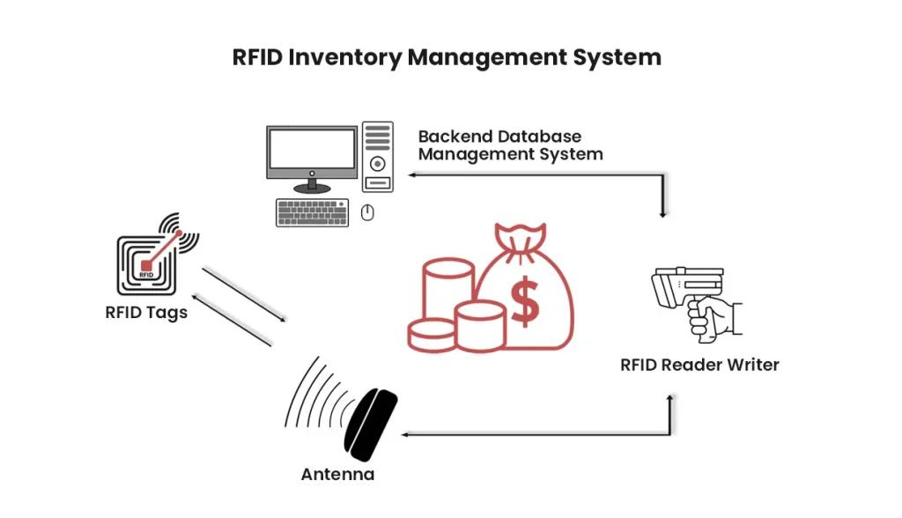9. Modules

Module 1: RFID Tag Registration
- Add new items.
- Assign RFID tags.

Module 2: Inventory Tracking
- Real-time scanning.
- Automatic stock updates.

Module 3: Alert System
- Low-stock warnings.
- Missing inventory alerts.

Module 4: Reporting
- Daily stock reports.
- Inventory movement history.

Module 5: User Management
- Admin login.
- Staff access control.

10. Flowchart
Start
|
v
Scan RFID Tag
|
v
Tag Registered?
/ \
No Yes
| |
Add Item Check Action
| |
Save Data IN / OUT
| |
Update DB
|
Generate Alert if Needed
|
Display Status
|
End

11. Expected Outcomes
- 95–99% inventory tracking accuracy.
- Reduced manual inventory checking.
- Faster stock audits.
- Real-time inventory visibility.
- Automatic report generation.

12. Future Enhancements
- Integration with IoT cloud platforms.
- AI-based demand forecasting.
- Mobile application support.
- QR code and RFID hybrid system.
- Multi-warehouse inventory synchronization.

13. Conclusion
The RFID Inventory Management System provides an efficient and automated solution for inventory tracking. By leveraging RFID technology, the system minimizes manual effort, improves stock accuracy, enables real-time monitoring, and enhances overall inventory control for organizations.

